**NOIDA INSTITUTE OF ENGG & TECHNOLOGY**

**DEPARTMENT OF CYBERSECURITY**

# Noida Institute of Engineering & Technology - NIET, Greater ...

# 

# **PROJECT REPORT**

EVENT REGISTRATION FORM

**Name : Bhoomika Arya Branch : CYS-A (3rd)**

**ROLL NO : 2201331720026**

**Year : 2022-2026**

**Submitted To : Mr. Sumit Sharma**

**NOIDA INSTITUTE OF ENGG & TECHNOLOGY**



**DEPARTMENT OF CYBERSECURITY**

# **BONAFIDE CERTIFICATE**

This is to certify that **Bhoomika Arya** of Branch **Cyber Security** has done project work on **Web Technologies** during the year 2023-2024 at the **NOIDA INSTITUTE OF ENGG & TECHNOLOGY**

**HOD Guide In charge**

**Cybersecurity Mr Sumit Sharma**

**Mrs. Bhawna Wadhwa**

**ACKNOWLEDGEMENT**

I would like to express my heartfelt gratitude to all those who have supported and guided me in completing my BTech project titled *Event Registration Form.*

First and foremost, I extend my sincere thanks to my project guide, **Sumit Sharma**, for their invaluable insights, unwavering support, and constructive feedback. Their expertise in the field of blockchain and decentralized finance has been instrumental in shaping the direction and success of this project.

I am deeply thankful to the faculty and staff of **Noida Institute of Engineering and Technology** for providing me with the necessary resources, knowledge, and an inspiring environment to undertake this research.

I would also like to acknowledge my peers and friends for their encouragement and for fostering a spirit of collaboration and learning throughout the course of this project.

Finally, I am profoundly grateful to my family for their continuous encouragement, patience, and motivation, which have been my pillar of strength throughout this journey.

This project has been a challenging yet enriching experience, and I am deeply appreciative of everyone who contributed to its completion.

**Bhoomika Arya**  
**2201331720026**

**Theory of Project**

This project explores the development of a responsive and user-friendly event registration form using HTML, CSS, and JavaScript. The form streamlines the sign-up process, providing a seamless experience for event organizers and attendees.

Event management involves challenges such as handling registrations, maintaining accurate participant records, and ensuring efficient communication. Traditional methods like paper-based forms or spreadsheets are prone to errors and inefficiencies. This project aims to solve these issues with a digital solution.

**Objective**

The primary objective of this project is to develop a user-friendly and responsive event registration form that simplifies the registration process. The form collects participant data and provides immediate feedback through interactive elements, enhancing both user experience and data management for event organizers.

**Specific Goals:**

1. Create a visually appealing form with CSS.
2. Enable user interaction and validation using JavaScript.
3. Ensure cross-device compatibility with responsive web design.
4. **Technology Overview**
5. **HTML (HyperText Markup Language):**
   * Serves as the backbone of the project, structuring the form with fields such as name, email, phone number, event selection, and additional options like dietary preferences or T-shirt size.
   * Utilizes semantic tags for better accessibility and SEO.
6. **CSS (Cascading Style Sheets):**
   * Enhances the visual appeal of the form through styling, including colors, fonts, and layout.
   * Implements responsive design using media queries to adapt the form for various devices.
7. **JavaScript:**
   * Adds interactivity and dynamic functionality, such as:
     + Real-time form validation for required fields.
     + Custom error messages for invalid inputs.
     + Auto-populating dependent fields (e.g., suggesting workshops based on event selection).
   * Facilitates seamless user experience

**Future Improvements**

*1. Backend Integration*

* *Database Storage:*
  + *Connect the form to a database (e.g., MySQL, MongoDB, or Firebase) to store participant data persistently.*
  + *Enable organizers to access and manage participant records through an admin pane*

**2. Payment Gateway Integration**

* **Allow participants to pay registration fees directly through the form using popular gateways like PayPal, Stripe, or Razorpay.**
* **Display payment confirmation and send an email receipt to the user.**

### **3. Event-Specific Features**

* **QR Code Integration:**
* **Generate a unique QR code for each registration, which can be scanned for check-ins during the event.**

**Conclusion**

The **Event Registration Form** project effectively demonstrates the importance of digital tools in streamlining event management processes. By leveraging modern web technologies like HTML, CSS, and JavaScript, the project provides a user-friendly, interactive, and responsive interface for participants to register with ease. It addresses the challenges of traditional registration methods, offering features such as real-time validation, accessibility, and scalability.

The project not only simplifies data collection for event organizers but also enhances the participant experience by ensuring accuracy and efficiency. It lays a solid foundation for further development, including backend integration, payment gateways, and advanced analytics.

In conclusion, this project reflects the potential of web-based solutions to improve operational efficiency and cater to evolving user needs. As events become increasingly diverse and complex, such a system can be adapted and expanded to support various functionalities, making it a valuable tool for event management in the digital era.

**Hardware Requirements**

1. **Development Machine:**
   * Processor: Intel i3 or equivalent (minimum); Intel i5 or above (recommended).
   * RAM: 4GB (minimum); 8GB or above (recommended for multitasking).
   * Storage: 256GB (minimum); SSD storage recommended for faster performance.
   * Display: Minimum 1366x768 resolution; Full HD (1920x1080) recommended.
2. **Additional Hardware (Optional):**
   * External storage device (USB or HDD) for backups.
   * Internet connection for downloading libraries and testing deployment.

**Software Requirements**

**1. Operating System**

* **Windows 10/11**, macOS, or Linux (Ubuntu, Fedora, etc.).

**2. Development Tools**

* **Code Editor/IDE:**
  + Visual Studio Code (recommended) or alternatives like Sublime Text, Atom, or Notepad++.
* **Web Browser:**
  + Google Chrome (recommended) or other modern browsers like Firefox, Safari, or Edge for testing.
* **Version Control:**
  + Git for version control and collaboration.
  + GitHub/GitLab/Bitbucket for repository hosting.

**3. Programming Languages**

* **HTML5**: For structuring the form and its elements.
* **CSS3**: For styling and responsive design.
* **JavaScript (ES6+)**: For interactivity and form validation.

**4. Libraries and Frameworks**

* Optional libraries to enhance functionality:
  + **Bootstrap** or **Tailwind CSS**: For faster UI styling.
  + **jQuery** (optional): For simplified DOM manipulation.
  + **FontAwesome**: For icons.

**5. Testing and Debugging Tools**

* **Browser Developer Tools** (e.g., Chrome DevTools): For debugging HTML, CSS, and JavaScript.
* **Validation Tools**:
  + W3C Validator for HTML and CSS.
  + JSLint/JSHint for JavaScript code quality.

**6. Deployment Tools**

* **Local Server:**
  + Live Server extension (for VS Code) for real-time preview.
  + XAMPP or WAMP (if simulating server-side features in future).
* **Cloud Hosting:**
  + Netlify, Vercel, or GitHub Pages for deployment and testing.

**7. Additional Tools**

* **Text Editors**: Markdown editors for documentation.
* **Graphics Tools** (optional): Canva, Figma, or Adobe XD for prototyping and design.

**Source Code:**

**HTML Code**

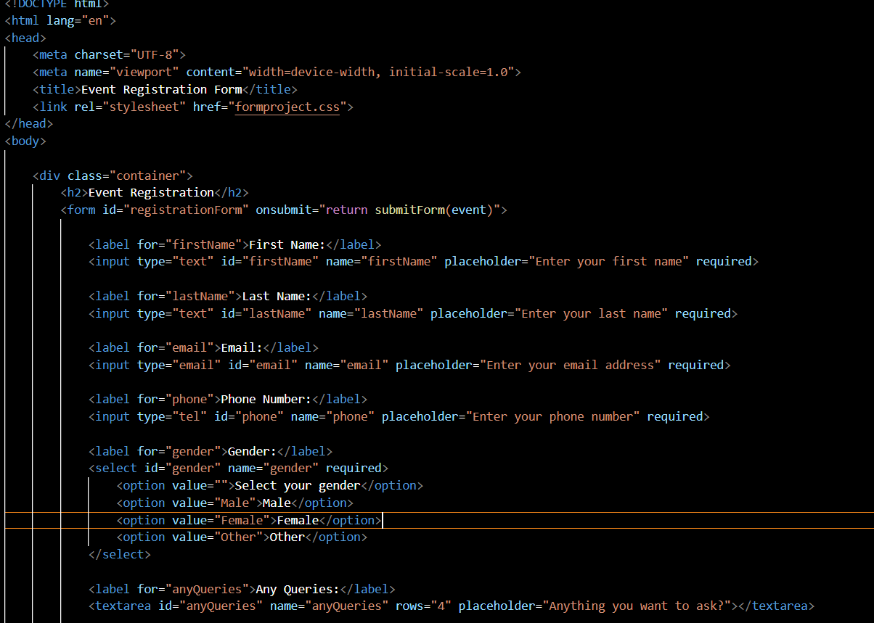

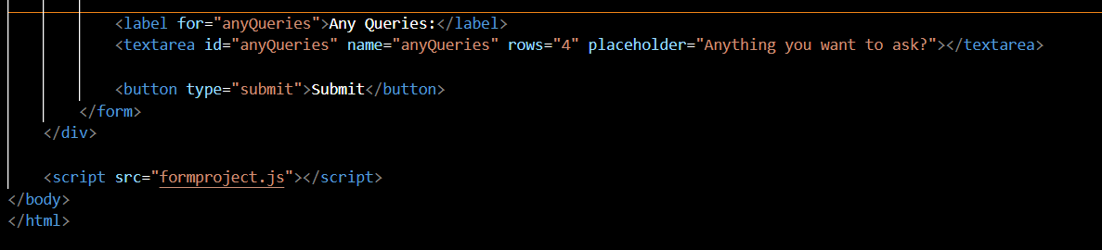

CSS Code

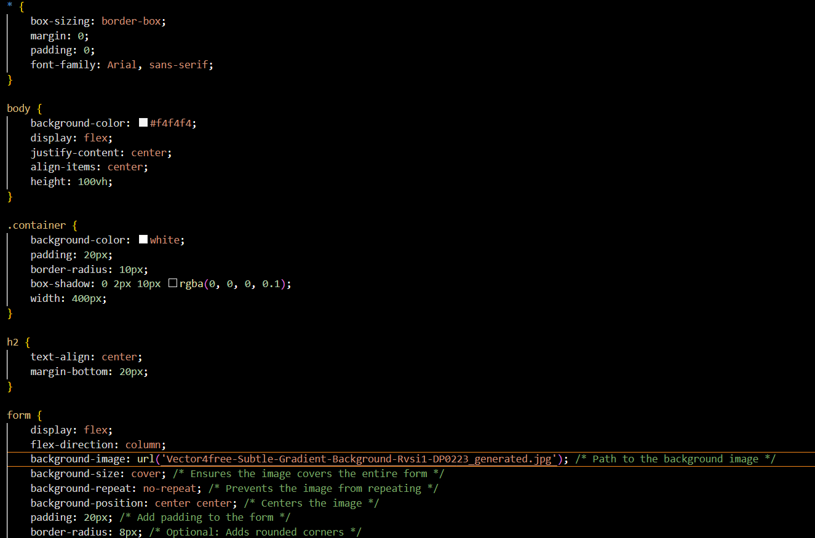

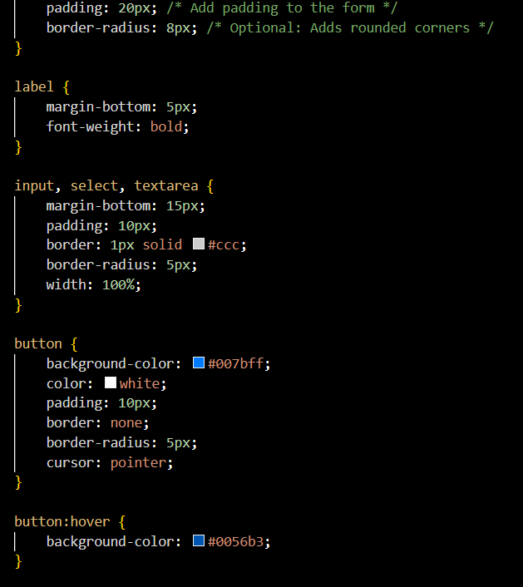

JAVASCRIPT CODE

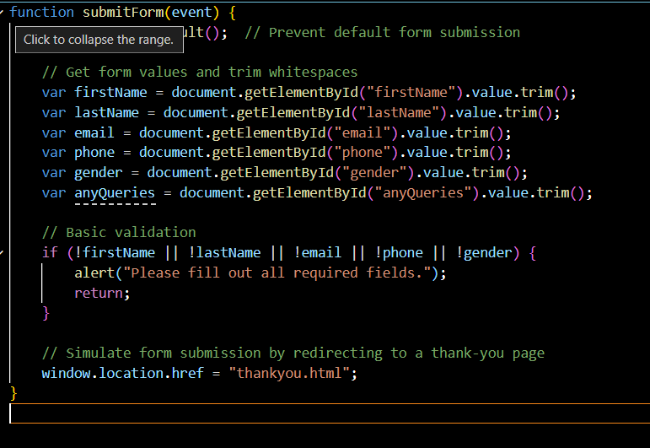

HTML CODE FOR thankyou Page

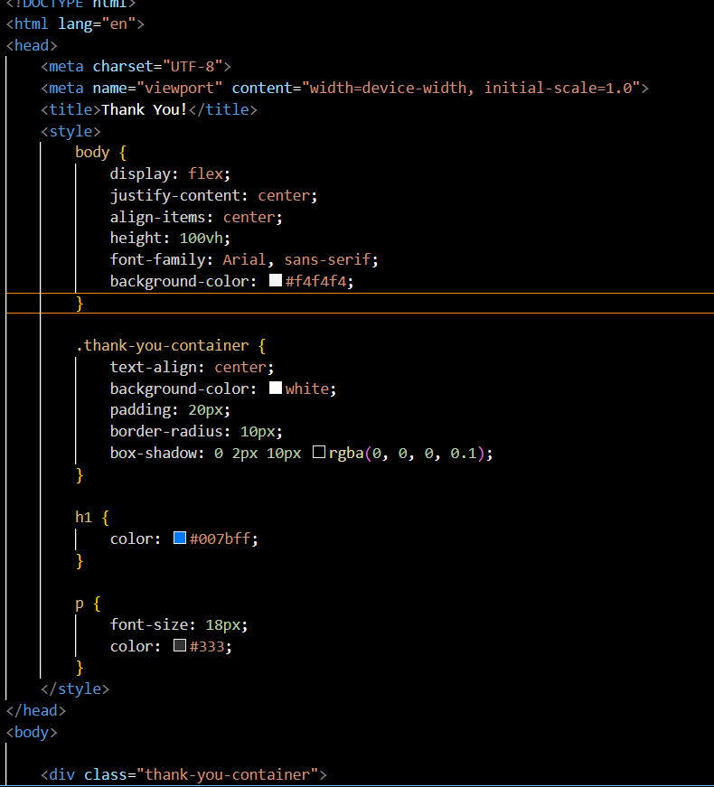

INPUT and OUTPUT

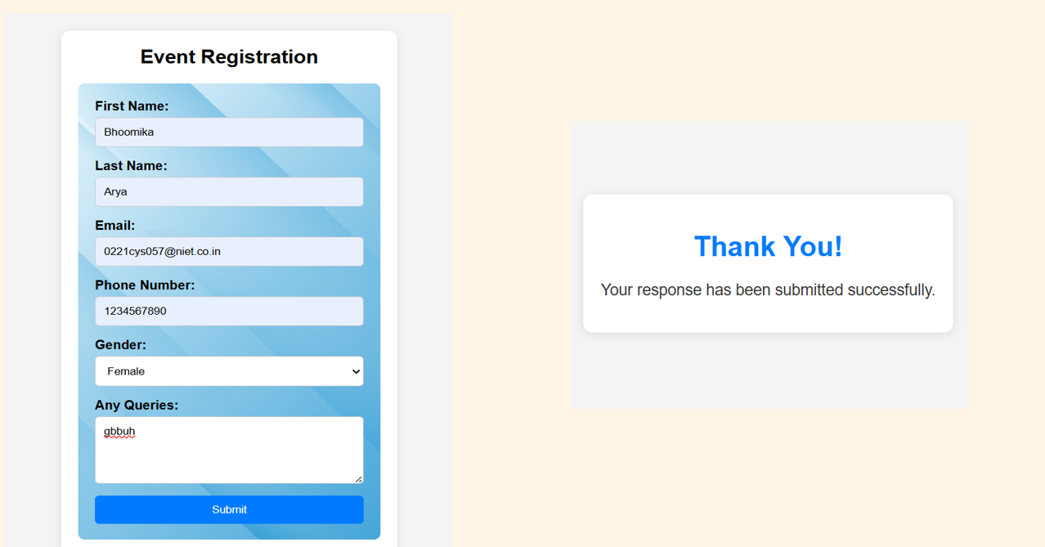

REFERENCES:

